CSI106 Homework 10: The FFT

You saw how we could make a square wave from sin waves. Well, the FFT or Fast Fourier Transform gives you a way to figure out what those coefficients are for the different harmonics. The square wave has the first, third, fifth, … and so on.

Remember the equation:

sin(t) + (1/3)sin(3t) + (1/5)sin(5t) + …

Those multipliers 1,3, and 5 are the harmonics of the fundamental frequency of the waveform.

To use the FFT, we need to use an IDE other than JES. We will go back to Idle because we need a module called numpy.

Run Idle and create a file called fft.py which is shown below:

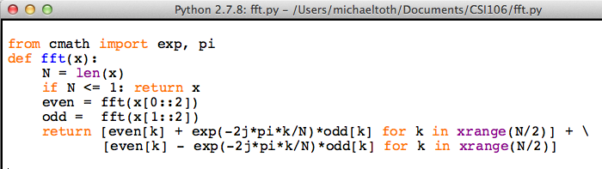

This creates a function for us called fft which expects a list of numbers (like [1,1,1,1]). Try it with [1,1,1,1] and see if you get the following.



Notice the result which is equivalent to [4,0,0,0] if you don’t use complex notation.

This means that the 0 frequency value is 4 and all other frequencies are 0. The 0 value of frequency is the DC value. If we had a list like [1,-1,1,-1] you might expect that the DC value or 0 frequency value would be 0 because the signal stays above the x axis as much as it stays below.



Indeed the 0 value is 0. The third frequency is 4. What this frequency is, is determined by the sampling frequency of the signal. Here’s an example signal.

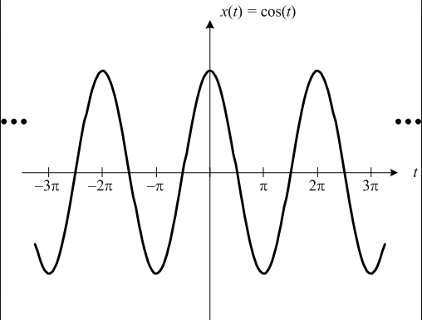

If t corresponds to time in this plot and our values we passed into the fft correspond to this signal, the signal has a frequency of 1/2π or about 0.16 cycles per second. (pretty low frequency!) So the FFT had one non-zero value in the third slot. Our sampling frequency is 1/π or about 0.32 samples per second.

Sampling twice as fast, gives [1,0,-1,0,1,0,-1,0] which produces an FFT of [0,0,4,0,0,0,4,0]. There is only one frequency present but we have two values there.